NOTRE DAME UNIVERSITY

Faculty of Engineering

ECCE Department

#### EEN 345

#### Computer Networks Laboratory

**Instructor:**

Dr. Wissam El Beaino

Report #3

**CCNA2 – VLANS and routing**

Due on:

24/5/2022

Submitted by:

Mohammad Diab

(20162542)

# I- Situation:

You have been appointed as a Network engineer in an FMCG (fast-moving consumer goods) company. The company has the following departments:

1. Finance
2. Humane Resources
3. Operations
4. Sales and Marketing

The company has two locations that are linked through a serial connection between two routers named Beirut and Jounieh. Beirut branch has the following VLANs:

Finance VLAN 10 - 192.168.10.0/24

HR VLAN 20 – 192.168.20.0/24

Operations VLAN 30 – 192.168.30.0/24

Management VLAN 99 – 192.168.99.0/24

Native VLAN50

In Beirut, there are three cisco catalyst 2960 switches installed. Each switch is assigned an IP from the management VLAN. Also, each switch contains users from all VLANs (add 3 PCs on each switch to simulate this). An additional management PC is connected to one of the switches. All switches are connected together and one of them is connected to Beirut router through Ethernet. All VLANs should be able to communicate with each other by configuring the router on a stick for Beirut. Assign IP addresses to all the PCs. Keep the first IP address of each subnet reserved to the default gateway. Also, assign IP addresses to all the switches.

In Jounieh branch, you must create multiple subnets out of the 192.168.10.0/24 network address space to create 8 subnets. The first subnet is used for the sales and marketing department. In this branch, you have only one cisco catalyst 2960 switch installed that is connected to Jounieh router through Ethernet. The second subnet is further subnetted to create 2 hosts per subnet. The first two addresses of the first subnet are used for the interfaces of the serial connection between Beirut and Jounieh.

Perform Static routing on Beirut and Jounieh. Test the connectivity. Each user should be able to ping all the remaining users in the network.

I used 192.168.100.0 instead because the serial 0/3/0 on Beirut router was overlapping with gig 0/0.10 (192.168.10.32 & 192.168.10.1)

Note: I have sent you an email, you can check it

# II- Implementation:

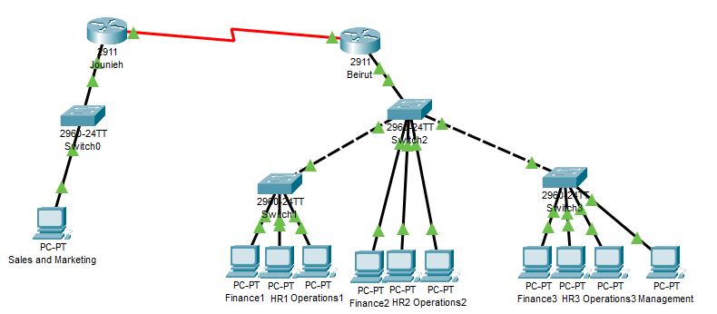

This topology was configured by following these steps:

Given the network 192.168.100.0/24 and default subnet mask 255.255.255.0

To further subnet this network we need to know how many subnets there are. We also need to how many borrowed and remaining bits are there.

Number of hosts per subnet = 2^ (borrowed bits) = 8 subnets

Borrowed bits = 3

Remaining = 5

Network becomes 192.168.100.0/27 and we move by 32 in each ip

|  |  |  |  |
| --- | --- | --- | --- |
| network id | subnet mask | host id range | broadcast id |
| 192.168.100.0 | /27 | 192.168.100.1-192.168.100.14 | 192.168.100.15 |
| 192.168.100.32 | /27 | 192.168.100.33-192.168.100.46 | 192.168.100.47 |
| 192.168.100.64 | /27 | 192.168.100.65-192.168.100.78 | 192.168.100.79 |
| 192.168.100.96 | /27 | 192.168.100.97-192.168.100.110 | 192.168.100.111 |
| 192.168.100.128 | /27 | 192.168.100.129-192.168.100.142 | 192.168.100.143 |
| 192.168.100.160 | /27 | 192.168.100.161-192.168.100.174 | 192.168.100.175 |
| 192.168.100.192 | /27 | 192.168.100.193-192.168.100.206 | 192.168.100.207 |
| 192.168.100.224 | /27 | 192.168.100.225-192.168.100.236 | 192.168.100.237 |

The first subnet is used for the sales and marketing department and the second subnet is further subnetted to create 2 hosts per subnet .The first two addresses of the first subnet are used for the interfaces of the serial connection between Beirut and Jounieh.

Remaining bits =5

Borrowed bits = 3

New Remaining bits = 2

Number of hosts per subnet = 2^ (remaining bits) – 2= 2 user IP addresses

So now all the default mask is /27 +3 = /30 for the two subnets

Becoming 255.255.255.252 (11111111.11111111.11111111.11111100) .So, the two IP addresses chosen are the first 2

|  |  |  |  |
| --- | --- | --- | --- |
| network id | subnet mask | host id range | broadcast id |
| 192.168.100.32 | /30 | 192.168.100.33-192.168.100.34 | 192.168.100.35 |
| 192.168.100.36 | /30 | 192.168.100.37-192.168.100.38 | 192.168.100.39 |
| 192.168.100.40 | /30 | 192.168.100.41-192.168.100.42 | 192.168.100.43 |
| 192.168.100.44 | /30 | 192.168.100.45-192.168.100.46 | 192.168.100.47 |
| 192.168.100.48 | /30 | 192.168.100.49- 192.168.100.50 | 192.168.100.51 |
| 192.168.100.52 | /30 | 192.168.100.53- 192.168.100.54 | 192.168.100.55 |
| 192.168.100.56 | /30 | 192.168.100.57- 192.168.100.58 | 192.168.100.59 |
| 192.168.100.60 | /30 | 192.168.100.61-192.168.100.62 | 192.168.100.63 |

## 

PCs: IP configuration

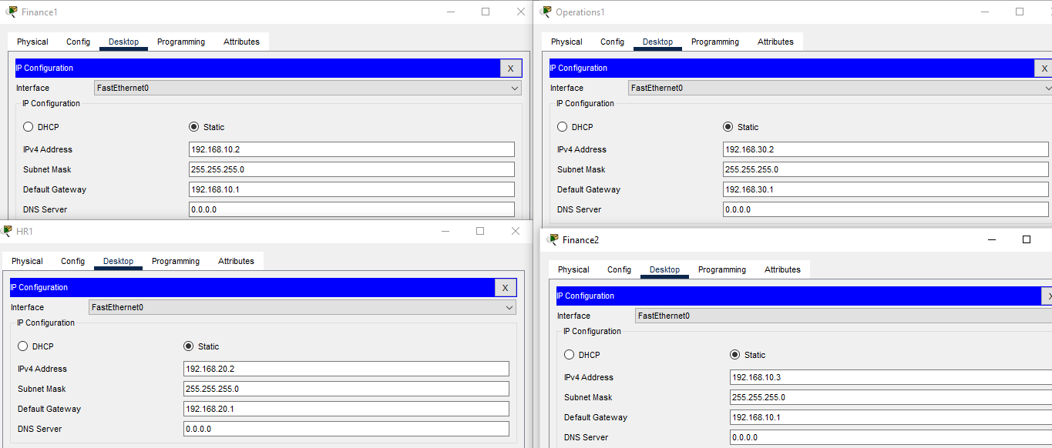

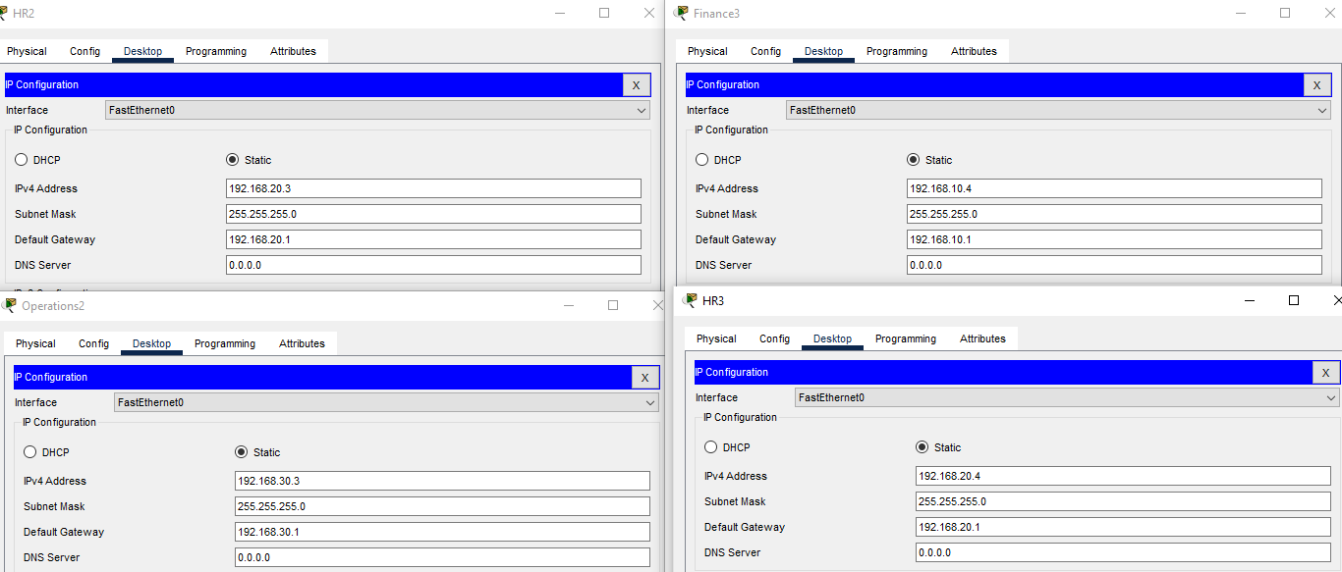

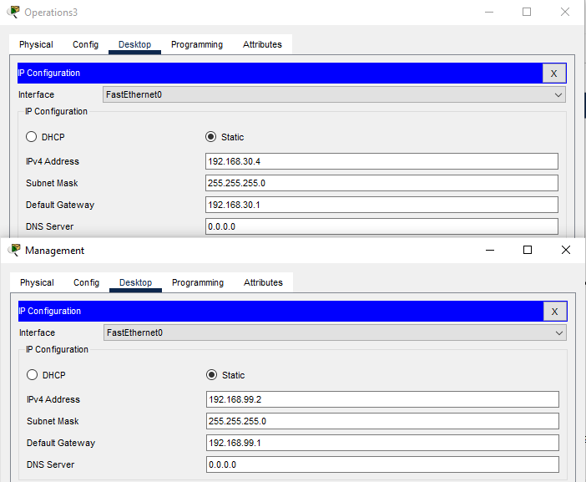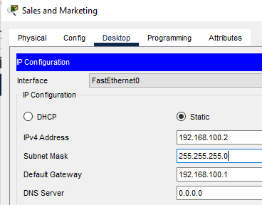

## Setting up the VLANS:

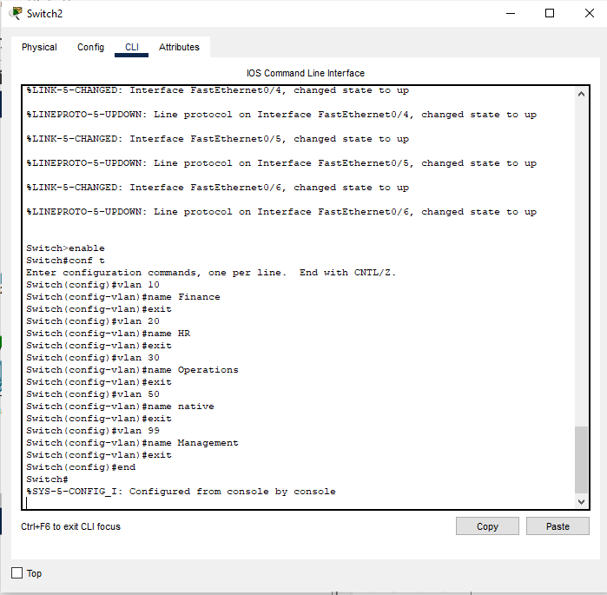

Vlan Configuration for the three switches

## IP Assignments for Beirut Network PCs and Switches:

Each PC was assigned a specific role and as such received a specific IP under the following rules:

* Finance PCs receive IPs in the 192.168.10.0 network related to vlan 10.
* HR PCs receive IPs in the 192.168.20.0 network related to vlan 20.
* Operation PCs receive IPs in the 192.168.30.0 network related to vlan 30.
* Management PCs receive IPs in the 192.168.99.0 network related to vlan 99.

As for the switches, the IP must be assigned in the management vlan and as such must be included in the 192.168.99.0 network along with the management PCs.

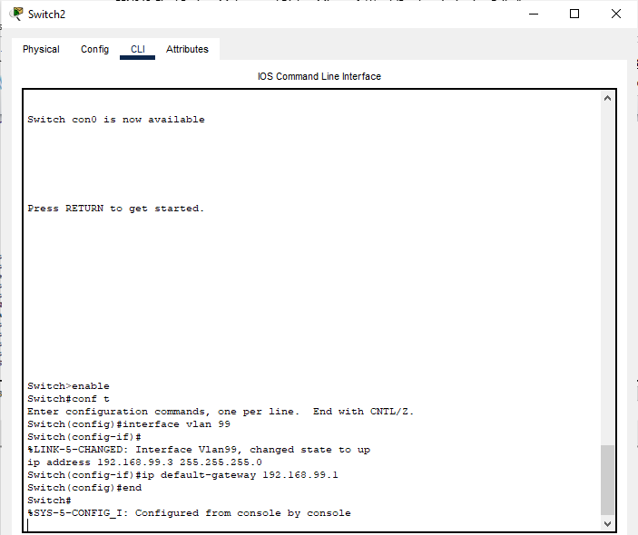

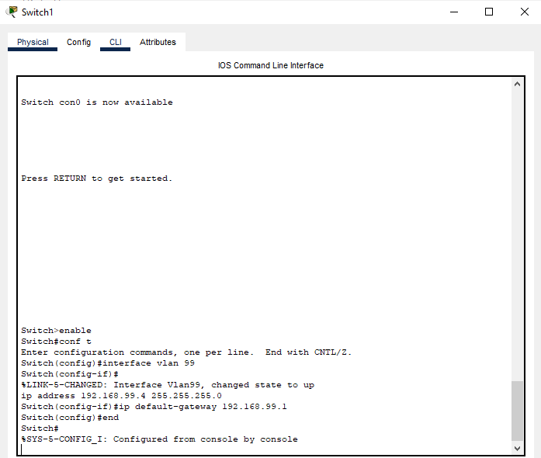

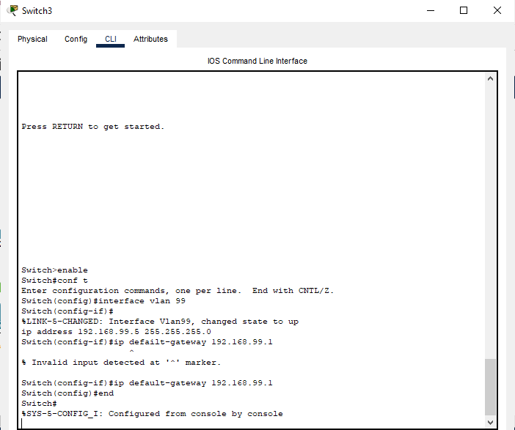

## Assigning the VLANS to switch ports:

For the switch to be able to communicate properly with the PCs, each PC must be assigned to its proper vlan. The finance PCs must be assigned to the finance vlans on its specific switch. The same can be said for all other different types of PCs and vlans. Now, to achieve this we must assign the switch interface connected to the specific PC the required vlan through the following commands:

conf t

Interface (specified interface)

switchport mode access

switchport access vlan (vlan id) 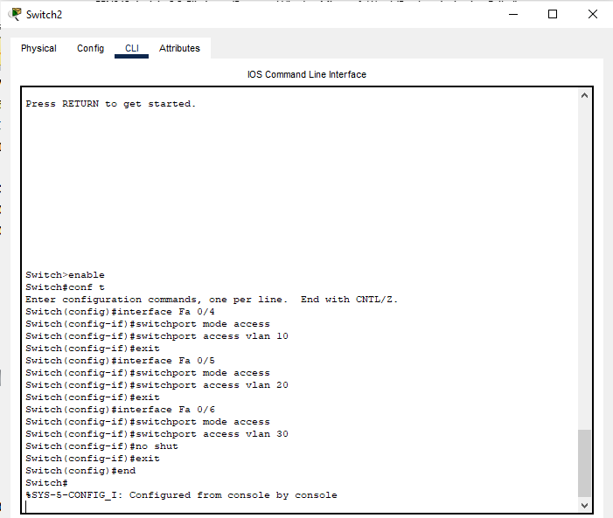

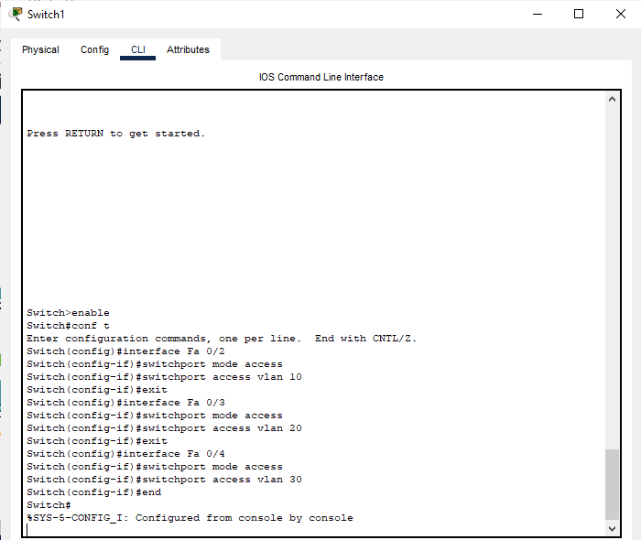

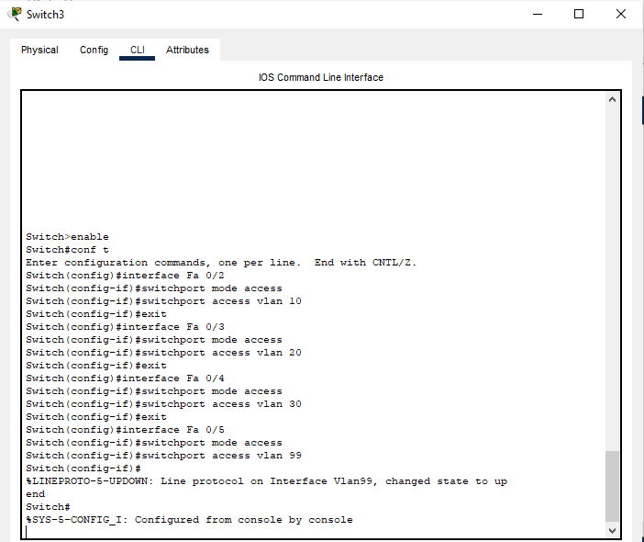

1. Configuring Jounieh Router:

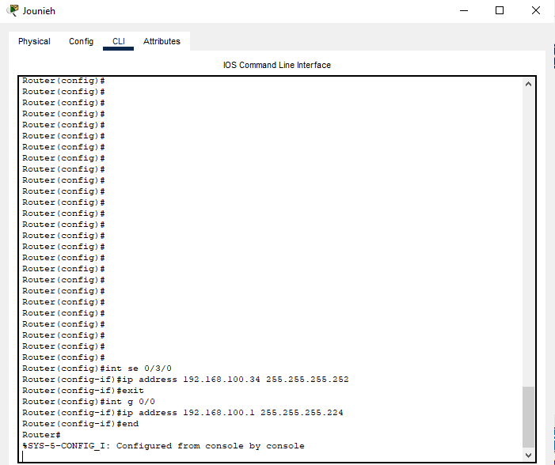



## Trunk Connections between the switches and the router:

For the switches to inter-communicate, trunk connections must be established. These connections will be assigned to the native vlan, in our case vlan 50.

For each interface where the switch is connected to another switch, we assign it to vlan 50, and allow connections to other vlans on the switch.

Moreover, you can notice that Switches 1 and 3 are only connected to their PCs and the central switch 2, so they only need 1 trunk VLan which is assigned to the default fa 0/1 (since they only need it when they are connected to Switch2). However, Switch 2 needs to connect to the 2 switches as well as the router so it needs 3 trunk VLans. The first FA port 0/1 is used to connect to the Beirut router while the next 2 (FA 0/2 and 0/3) are used to connect and allow communication between the 2 switches.

The main commands used here are:

switchport mode trunk

switchport trunk native vlan 50

switchport trunk allowed vlan 10,20,30,50,99

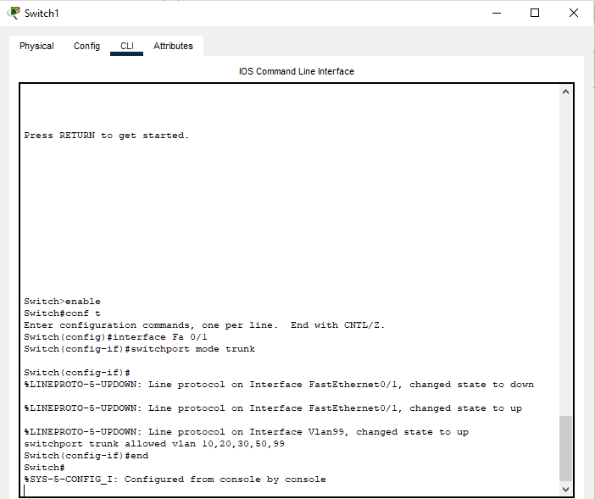

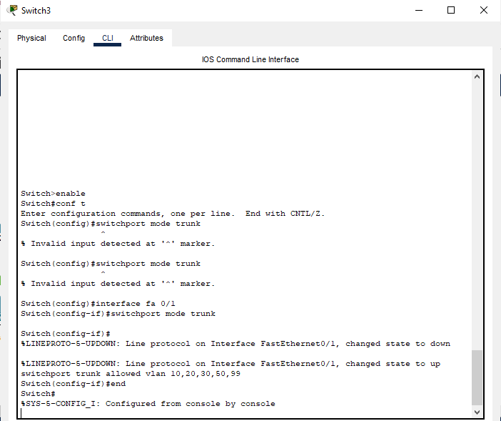

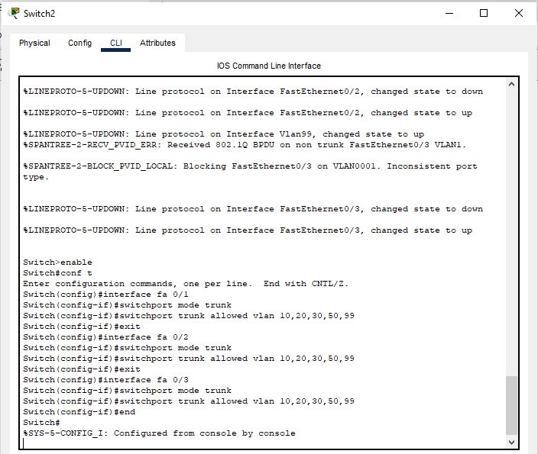

## Routing on a Stick configuration:

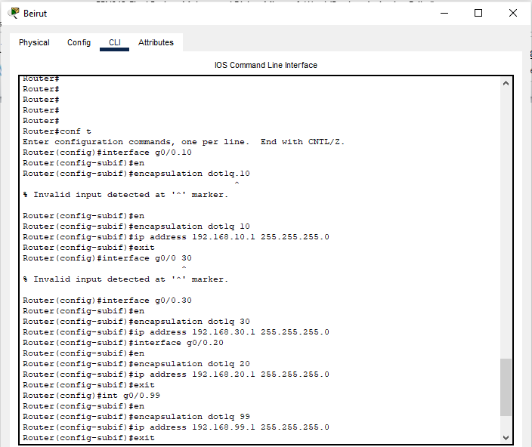

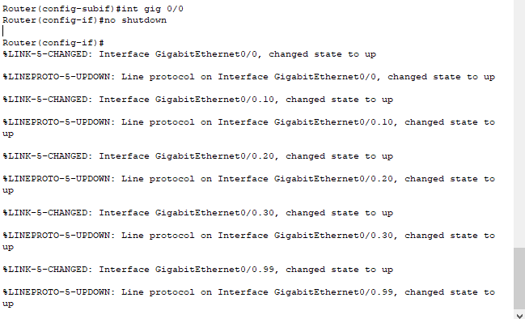

We use dot1Q encapsulation in order for the router to recognize that the information coming into the sub-interfaces of 0/0.10, 0/0.20, 0/0.30 and 0/0.99 are all from VLans already configured on the switches. That way we assign the default gateway of these VLans onto each sub-interface on the router so it can recognize the data it receives and forward it accordingly

## Assigning the adequate addresses:

The routers were assigned IP addresses form the subnetted second subnet (192.168.100.34 for Jounieh and 192.168.100.33 for Beirut) at each port of the serial interface. The 192.168.100.0 network was assigned at the port of the Jounieh router with the adequate default gateway.

The main commands here are

ip address and ip default gateway.

## Static Routing:

Static routing was performed using the ip route command. For the Beirut router, the only network present at the gigabit port of the Jounieh router was added. For the Jounieh router, the subnets used for the vlans were added (192.168.10.0, 192.168.20.0, 192.168.30.0, 192.168.99.0).

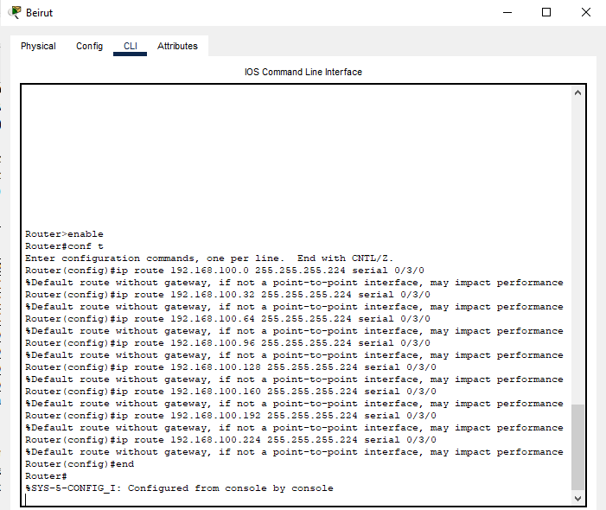

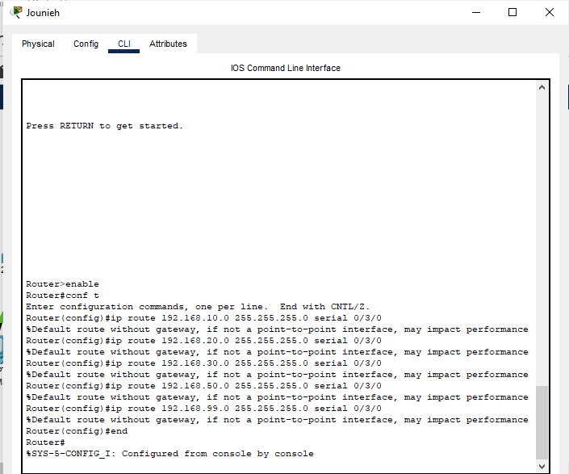

Each router has to be configured so that it ‘sees’ all the subnets present on the other router. Beirut has to recognize all the subnets found across the Jounieh router and the Jounieh router has to recognize all the Vlan addresses found on Beirut.

## Connectivity Check:

Different scenarios were successfully tested with the ping command.

* This is HR1 pinging Management (IP 192.168.99.2) on a different switch on the same router, and pinging the Sales and marketing (IP 192.168.100.2) on another router.

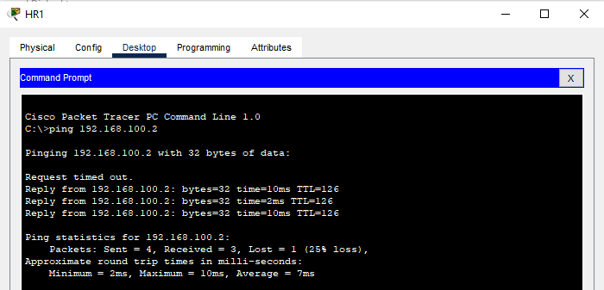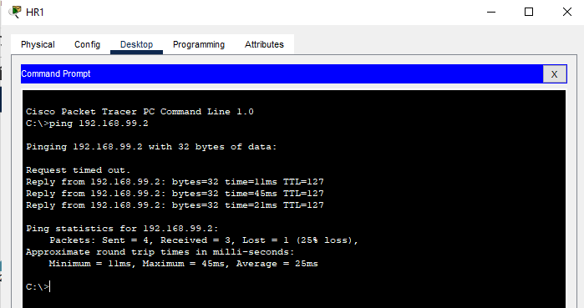

* This is Operations2 pinging HR1 on the same router, and the Sales and marketing on Jounieh router.

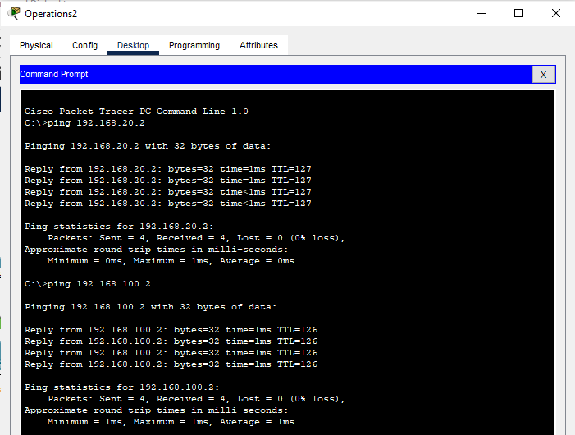

* Finally, this the Sales-Marketing PC pinging itself then pinging Operations3 found on the Beirut router.

